Microservices Tutorial #3 - Project Architecture & Components - Complete Notes

Introduction
This is the third video in the Microservices series. The previous two videos covered:
- Prerequisites
- Why Microservices (monolithic vs microservices)
This video covers:
- What application/project we'll build throughout this course
- Understanding all the microservices components in detail
Request to viewers: Subscribe to the channel and share the video with friends so more people can benefit.

The Project: Hotel Review / Rating System

Overview
Throughout this course, we'll build a Hotel Review System (or Hotel Rating System) where:
- A user can rate a hotel
- Multiple microservices communicate with each other
- Different services handle different concerns
Critical: Understand this architecture clearly — otherwise confusion and ambiguity will arise during the course.

The Three Core Microservices

1. Hotel Service
Purpose: Stores all hotel information.
Data stored (examples):
- Hotel name
- Hotel description
- Hotel location
Operations:
- Get hotel information
- Create hotel information
Database: Has its own database — DB1

2. User Service
Purpose: Stores all user information.
Data stored:
- User details (e.g., "Durgesh" and their info)
Operations:
- Store and manage users
Database: Has its own database — DB2

3. Rating Service
Purpose: Stores and manages ratings.
Data stored:
- Rating information
- Which user gave which rating to which hotel
Database: Has its own database — DB3

Key Architecture Principles

Independent Projects and Databases
- The three services are separate projects (separate codebases)
- Each service has its own database (DB1, DB2, DB3)
- Each service only accesses its own data

Tech Stack Flexibility
- Different tech stacks per service are allowed:
  - Hotel Service → Python
  - User Service → Java/Spring Boot
  - Rating Service → Node.js + MongoDB
- Or all services can use the same tech stack (e.g., Spring Boot) — different projects, different codebases
Key point: "Different codebase" means:
- Different project
- Different code
- Same or different language — both work
Databases can also differ:
- Different databases per service (not required to be same type)

Service-to-Service Communication Example

The Flow: "Get User with Hotel Ratings"
Scenario: Client wants user #245's info and their ratings.
What happens:
- Client → User Service: Requests user 245's information
- User Service → knows only user info (name, etc.) — does NOT have rating data
- User Service → Rating Service: Calls Rating Service to get all ratings given by user 245
- Rating Service returns: All ratings by user 245, including which hotel each rating is for
- User Service → Hotel Service: For each rating, calls Hotel Service to get hotel details
- Hotel Service returns: Hotel information for each rated hotel
- User Service compiles everything: User info + ratings + hotel details
- User Service → Client: Returns the complete compiled response

Why This Communication Is Needed
- User Service doesn't have ratings data
- Rating Service doesn't have hotel data
- Hotel Service doesn't have user data
- Each service has only its own data — they MUST communicate to answer complex queries

Communication Direction
- User Service → Rating Service (fetch ratings)
- User Service → Hotel Service (fetch hotels for each rating)
- Communication via REST APIs

Additional Microservices Components

1. Config Server (Configuration Server)
Problem solved: Many configurations will be repeated across services (and cause confusion/duplication).
Solution:
- Store all configurations in a centralized Config Server
- Config Server stores configurations on GitHub (Git-based config server)
How it works:
- Config Server holds configurations for Rating Service, User Service, Hotel Service
- Services fetch their config from the Config Server
- If a config is repeated across services, only change it once in Config Server

2. API Gateway
Problem solved: The three services have different URLs — client would need to know all of them.
Solution: Use API Gateway as a single entry point.
How it works:
- Client sends ALL requests to the API Gateway
- API Gateway routes the request to the appropriate service:
  - User Service
  - Hotel Service
  - Rating Service
- Client doesn't need to know individual service URLs
Flow:
text
Client → API Gateway → (User Service | Hotel Service | Rating Service)

3. Authentication / Authorization
Problem solved: Only authenticated users should access services.
Solution: Implement authentication/authorization.
How it works:
- Client sends request with authentication credentials
- If authenticated → request is allowed through
- If not authenticated → request is rejected
Implementation:
- Use Spring Security
- Use OAuth (or OAuth2)
- Services check authentication status before processing requests

4. Service Registry (Service Discovery)
Problem solved: Each service has its own IP address and port. IP/port may change over time. Clients don't know how to find services.
Example of the problem:
- Rating Service: IP 192.168.56.1, port 88 (or 001)
- User Service: IP 002, port 88
- Hotel Service: IP 003, port 88
- IP/port may change — hard to track
Solution: Service Registry — a centralized server where all services register themselves.
How it works:
- Each service registers itself with the Service Registry
- Service Registry tracks all services:
  - Service name
  - IP address
  - Port number
  - Status (UP/DOWN)
  - Multiple instances (if load-balanced)
- Client/Other services use the service name to call a service (not IP)
- Service Registry resolves the name to the current IP
Benefits:
- Track all services: See all registered services, their status (up/down), IP, port
- Call by name: Instead of hardcoding IPs, use service names (e.g., call "user-service" instead of "192.168.56.2:88")
- Load balancing: Service Registry handles load balancing across multiple instances
- No IP changes needed: Even if the IP changes, the name stays the same
Implementation:
- Use Eureka (Netflix Eureka) — most common
- Other options available
Why It's Important:
- If a service is down, Service Registry knows and reflects that
- If multiple instances are running, Service Registry shows all and manages routing
- Eliminates hardcoded IPs/ports

Complete Architecture Diagram
text
┌──────────────┐
│ Client │
└──────┬───────┘
│
▼
┌──────────────┐
│ API Gateway │
└──────┬───────┘
│
┌──────────────┼──────────────┐
│ │ │
▼ ▼ ▼
┌──────────────┐ ┌──────────────┐ ┌──────────────┐
│ User Service │ │Hotel Service │ │Rating Service│
└──────┬───────┘ └──────┬───────┘ └──────┬───────┘
│ │ │
▼ ▼ ▼
┌─────┐ ┌─────┐ ┌─────┐
│ DB2 │ │ DB1 │ │ DB3 │
└─────┘ └─────┘ └─────┘

┌─────────────────────────────────────────────┐
│ Config Server (Git-based) │
│ - Centralized configurations │
│ - Used by all services │
└─────────────────────────────────────────────┘

┌─────────────────────────────────────────────┐
│ Service Registry (Eureka) │
│ - All services register here │
│ - Track status of each service │
│ - Enables service discovery by name │
└─────────────────────────────────────────────┘

┌─────────────────────────────────────────────┐
│ Authentication (Spring Security/OAuth) │
│ - Verify user before service access │
└─────────────────────────────────────────────┘
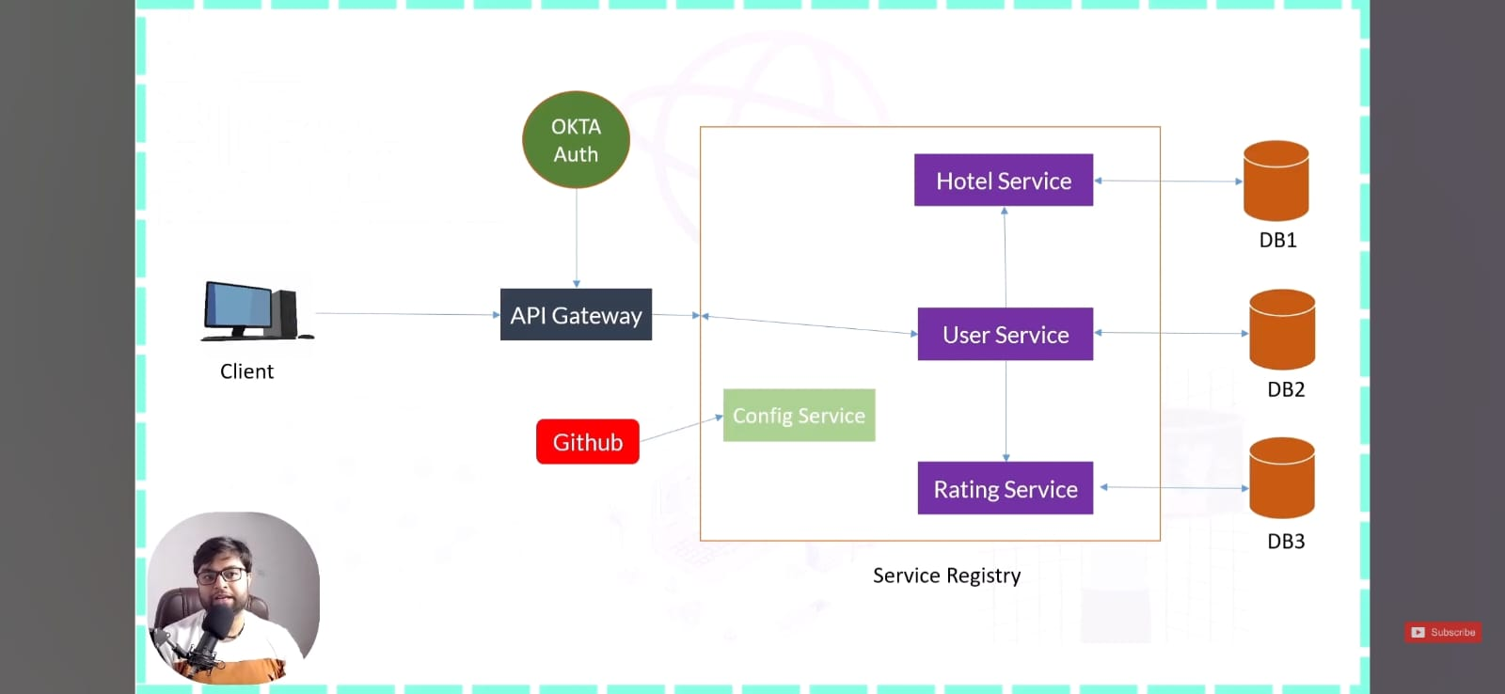

Detailed Component Summary
Component | Purpose | Technology Used
Hotel Service | Store/manage hotel info | Any (Spring Boot, Python, etc.)
User Service | Store/manage users | Any (Spring Boot, Python, etc.)
Rating Service | Store/manage ratings | Any (Spring Boot, Node.js, etc.)
Config Server | Centralize configs (stored on GitHub) | Spring Cloud Config
API Gateway | Single entry point, route requests | Spring Cloud Gateway / others
Authentication | Verify users before access | Spring Security + OAuth
Service Registry | Track services, enable discovery | Eureka

What We'll Learn Throughout the Course

Practical Topics
- How to build microservices (each service independently)
- How services communicate with each other (REST APIs)
- How to use a Config Server for configurations
- How to implement API Gateway
- How to implement Spring Security + OAuth for authentication
- How to implement Service Registry (Eureka)
- Load balancing via Service Registry
- All the practical implementation

Each Component in Detail
- Config Server: Store configs on GitHub, fetch configs in services
- API Gateway: Route requests from one entry point
- Authentication: Secure services with Spring Security/OAuth
- Service Registry: Register services, call by name, discover services

Service Registry - Deep Dive

What It Is
A centralized registry server where all microservices register themselves.

What It Tracks
- Service name: e.g., "user-service", "hotel-service", "rating-service"
- IP address: Current IP where the service is running
- Port number: Port the service is listening on
- Status: UP/DOWN
- Multiple instances: If a service is scaled (multiple replicas), all are listed

How It Solves the Problem
Without Service Registry:
- Client must know exact IP + port of each service
- IP or port changes → all client code breaks
- Hard-coded IPs in code → difficult to maintain
With Service Registry:
- Services register themselves
- Clients call by service name (e.g., http://user-service/api/users/245)
- Service Registry resolves name → IP + port
- IP changes internally → clients see no difference

Load Balancing
- If multiple instances of a service exist (e.g., 3 instances of User Service), Service Registry distributes requests across them
- Automatic load balancing

Eureka
- Most common Service Registry implementation
- Part of Netflix OSS ecosystem
- Built into Spring Cloud
- Simple integration with Spring Boot services

Example
Register:
text
Service: user-service
IP: 192.168.56.2
Port: 88
Status: UP
Service discovery:
- Instead of: http://192.168.56.2:88/api/users/245
- Use: http://user-service/api/users/245

Monolithic vs Microservices Architecture in This Project
Without microservices (all-in-one project):
- Everything in one Spring Boot project
- Single codebase
- Single database
- Single deployment
- Hard to scale
With microservices (this project):
- Three separate projects: User, Hotel, Rating
- Three separate databases
- Services communicate via REST APIs
- Independent deployment, scaling
- Cloud-native ready

Next Video Plan
The next video will:
- Start building the actual services
- Build in this order:
  - User Service (first)
  - Rating Service
  - Hotel Service
- Make them communicate with each other
- Slowly introduce components:
  - Config Server
  - API Gateway
  - Service Registry
  - Authentication
- Build the complete microservices system step-by-step

Key Takeaways
- Project: Hotel Review/Rating System with 3 services (User, Hotel, Rating)
- Three core services:
  - User Service (own DB — DB2)
  - Hotel Service (own DB — DB1)
  - Rating Service (own DB — DB3)
- Each service has:
  - Independent project
  - Independent codebase
  - Independent database
  - Independent deployment
- Services communicate via REST APIs:
  - User Service → Rating Service (fetch ratings)
  - User Service → Hotel Service (fetch hotels per rating)
- Additional components to implement:
  - Config Server: Centralize configs (stored on GitHub)
  - API Gateway: Single entry point for all requests
  - Authentication: Spring Security + OAuth
  - Service Registry: Eureka — track services, discovery by name, load balancing
- Tech stack flexibility: Different languages/tech stacks allowed per service
- Service Registry benefits:
  - Track all services and their status
  - Call services by name (not IP)
  - IP changes don't break clients
  - Load balancing across instances
  - Eureka is the most common implementation
- Course scope: Complete end-to-end implementation — building services, communication, config server, API gateway, security, and service registry

Interview/Reference Notes
Common interview question: "Design a hotel rating system using microservices."
Answer structure:
- 3 services: Hotel, User, Rating
- Each with own DB
- API Gateway for routing
- Config Server for configs
- Service Registry for discovery
- Auth Service for security
- REST APIs for inter-service communication
- Explain the query: "Get user with their ratings and hotel details" → shows how services collaborate

Summary
This video laid out the complete blueprint for the microservices project we'll build:
- Domain: Hotel Review/Rating System
- Core services: User Service, Hotel Service, Rating Service (with independent databases)
- Infrastructure: Config Server, API Gateway, Service Registry, Authentication
- Communication: REST APIs between services
- Build order: User → Rating → Hotel → then add components one by one
- Everything hands-on: No shortcuts, all practical implementation throughout the series
The next video begins hands-on implementation with the User Service.

